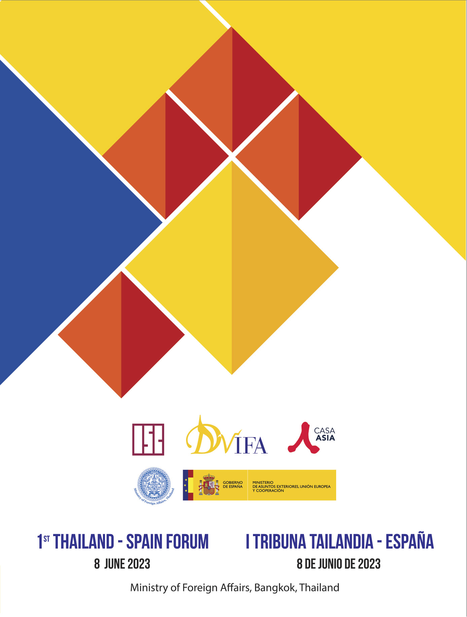

I THAILAND-SPAIN FORUM
Bangkok, June 8, 2023

VENUE:
Narathip Auditorium, Ministry of Foreign Affairs. Kingdom of Thailand
Address: Ministry of Foreign Affairs, 443 Sri Ayudhya Road, Bangkok 10400

JUNE 8, Thursday
8:30-9:00 h. Registration

9:00-9:10 h. Welcoming remarks:
- Dr. Anuson Chinvanno, Director of the International Studies Center (ISC), Thailand
- Mr. Javier Parrondo, Director General of Casa Asia

9:10-9:30 h. Opening speeches:
- Ms. Busadee Santipitaks, Deputy Permanent Secretary, Ministry of Foreign Affairs, Thailand
- Mr. Javier Salido, Director General for North America, Eastern Europe, Asia and the Pacific. Ministry of Foreign Affairs, European Union, and Cooperation of Spain

9:30-9:35 h, GROUP PHOTO

9:40.11:10 h. Session 1: Geopolitical Changes in the Indo-Pacific. Views from Thailand and Spain (Time: 1h 30’) (English)
- Moderator: Dr. Walaya Jariyadham, Fellow at the International Studies Center (ISC)

Speakers:
Mr. Emilio de Miguel, Ambassador at-Large for the Indo-Pacific and Director of the Casa Asia Centre-Madrid
Dr. Javier Gil, Professor of International Relations. Comillas Pontifical University.
Ambassador Sihasak Phuangketkeow, Former Permanent Secretary, MFA, Thailand.
Dr. Jittipat Poonkham, Associate Professor and Associate Dean for International Affairs, Faculty of Political Science, Thammasat University
Q&A
11:10-11:30 h, COFFEE BREAK

11:30-13:00 h. Session 2: Good practices of Thailand and Spain in the tourism sector. Opportunities for collaboration. (Time: 1h 30’) (English)
- Moderator: Ms. Mónica Sánchez, Tourism Counsellor at the Embassy of Spain in Singapore, and Director of the Spain Tourism Board - Southeast Asia, Australia & New Zealand

Speakers:
- Ms. Yolanda Perdomo, Director, MADRID TURISMO by IFEMA MADRID
- Mr. Ernesto Guerra, General Manager, MELIÁ KHO SAMUI
- Dr. Weerasak Kowsurat, Former Minister of Tourism and Sports
- Ms. Ben Montgomery, Vice-President, and Chairperson of International Affairs. Thai Hotels Association
Q&A

13:00-14:30 h. LUNCH

14:30-16:00 h. Session 3: Promotion of the Spanish language and culture in Thailand and of the Thai language and culture in Spain (Time: 1h 30’) (Thai and Spanish with simultaneous interpretation)
- Moderator: Dr. Carmen Pastor, Academic Director, Instituto Cervantes

Speakers:
- Dr. Prairin Simma, Assistant Professor, Faculty of Humanities, Ramkhamhaeng University
- Mr. Javier Galván, Director, Instituto Cervantes of Manila and Coordinator of Cervantes Centres in Southeast Asia
- Dr. Kittichai Suthasinobon, Associate Professor and Head Department of Curriculum and Instruction, Faculty of Education, Srinakharinwirot University
- Dr. Surat Jongda, Assistant to the President, Bunditpatanasilpa Institute, Ministry of Culture
Q & A

16:00-16:20 h. COFFEE BREAK

16:20-16:30. Closing remarks:
- Ms. Inmaculada Riera, Director General, Spanish Chamber of Commerce

